**Assignment #2**

**Introduction to Linux**

**Ammad Ali**

Problem Statement:

T om Cruise has implemented his own flavor of customized Ubuntu version but he wants to make sure if it has the ability to kill the programs according to the user will. He has a script running on the system named “Ghost_Protocol.py”. He has asked you to kill that script through the terminal.

Solution:

Step 1:

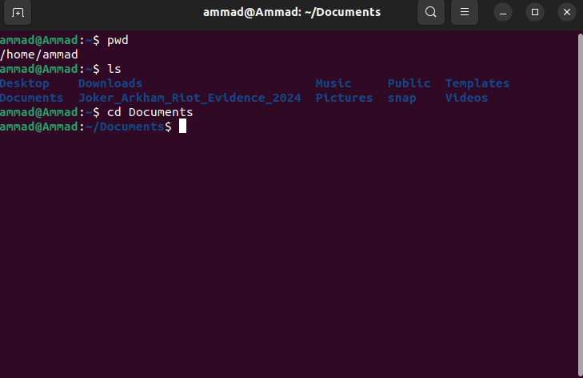’

Checking which currently I was currently in and the files that are present in that directory. Entered “Documents” directory by using the cd command.

Step 2:

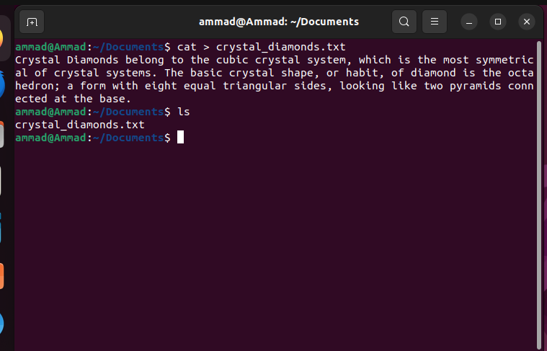

Created a text file with the name “crystal_diamonds.txt” using the cat command and then writing the text that has to be saved in the text file. Pressed Ctrl+D to save and exit the file. Upon running the ls command, we can see that the documents directory now has the text file that we created.

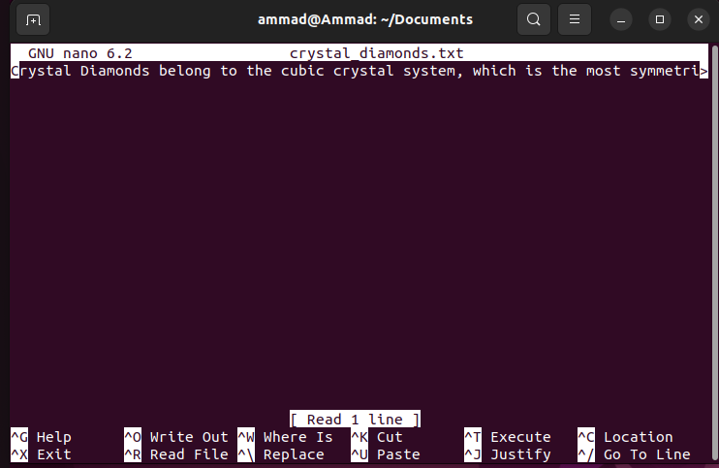

We can run the nano command with the file name after it to open the text file and we can see that the file has the text that we entered.

Step 3:

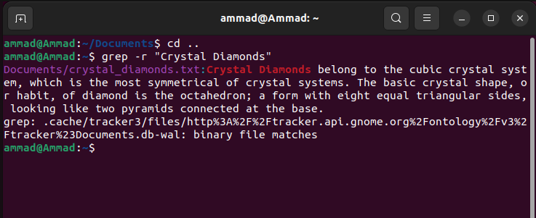

Then I went back to the directory “/home/ammad” using cd .. and used the grep command with -r to find the words “Crystal Diamonds” in that directory. This command returned us the relative path of the file, which was “Documents/crystal_diamonds.txt” and the text that was written in the file while also highlighting the searched words.